PERSONAL FINANCE MANAGEMENT

Dadireddy Manogyna Satya Reddy   
*2300031113 CSE*  
*KL University*Guntur, India  
2300031113@kluniversity.in

Aasritha Sai Panuganti  
 *2300031603 CSE*  
 *KL University* Guntur, India  
2300031603@kluniversity.in

Thummepalli Ruchitha  
*2300033231 CSE*  
KL UniversityGuntur, India  
2300033231@kluniversity.in

*Abstract*—This software development project is specifically targeting to create a complete personal finance management tool for the users to track their expenses and incomes, set budgets and track how they stand with these budgets and even more. The anticipated features include easy to use with secure login methods; easy way of tracking expenses; and a budget that is customizable for each user’s personal needs. The application will have let the users subset their expenses, create budgets, and view their summary in the form of graphs and charts.

Keywords—personal finance, budgeting application, financial management, savings, expense tracking, mobile app development, digital finance

# Introduction

Modern life is impossible without applications that are designed to help manage personal funds, for those who want to take their financial situation under control. This document provides a framework when conducting research on the design, development and consequences of these applications. This template has incorporated formatting features that ensure that papers presented to a conference or journal have similar formats.

The project aims at creating an application that will enable a user to manage personal finance using tools and features. This application will include safety considerations from the development phase of the application which will entail incorporating security features in the design phase let alone two factors’ authentication for financial details. Security of data is critical, with all user’s data and/or financial details protected to meet various data protection laws including GDPR. Besides, the application will contain an accurate expense tracking system whereby the users input or sync their expenses with the app and input categories. This feature will give users more comprehensive spending records of their spending in different categories like food, rent as well as entertainment and will also make users conscious of their spending via an alert feature if the user spending is close to or has gone over their spending limit.

It is most common for a correctly designed finance mobile application to include tools for expense tracking and budgeting, as well as data visualization. Such applications are embedded with user-friendly interface, primarily setting themselves, to demystify what would otherwise be complex, in the area of expense planning and management among users of any level. This paper outlines the main features, interface factors, and technical specifications of building a personal finance management application.

Also, the application will include all-around budgeting features that will allow designing the unique and most efficient budgeting for each user following his or her income and spending behavior. These tools will include both the regular and the planned budgetary strategies, and a possibility to manage the daily expenses, as well as achieve long-term goals. You can make personal mileage, business or any other type of targets and get regular notifications and persuasion letters in order to stay on track.

It will also include an AI chatbot which will offer users various options relative to their budget, share recommendations concerning their expenses based on the calculated expenses, and answer any questions the user may have. CHallenges proposed by this app, which securely and centred on the users’ needs offer the options that are delivered with the help of AI, do not only improve money management, but also expand the user’s financial literacy and help him or her make wiser decisions that are based on the available data. With this entire range of tools the project aims at establishing improved financial-cycle of spending and saving, as well as helping users to live a financially stable life in the short term and further.

An introduction to managing your own money :

It is important especially in the present challenging economic situations in a world where people demand to exercise some level of control over their finances. The financial monitoring and budgeting apps are used by people to keep track of their expenses, plan their financial objectives, and use evidence-driven choices.

Why Tracking is Important and the Use of Tracking and Budgetary Tools:

Budgetary tools must therefore be devised like never before. Some of the existing research evidence indicates that by having the tailor-made tools to track personal budgets, many users are inclined to maintain their financial targets. This application needs to align users with the necessary tools to track their expenses, potential and necessary expenditures as well as make budgets and envision their thriving future.

Project Objectives and Scope:

This project will involve the creation of a secure login and password, together with features such as interactions, expense tracking, budgeting, data analysis, and an AI ChatBot. The concept behind the application is primarily to enhance the financial literacy among the target consumer and assemble the tools that will ensure that the user is capable of making the right financial decisions.

# Project Overview

The Personal Finance Management application proposal implemented in the present paper presupposes equipping the users with the necessary tools to manage their money, which are a set of easy-to-use tools for tracking expenses, creating budgets, analyzing the spending and so on. This application is of target to people who want to improve their level of finance and do wiser budgeting in as easy to use interface. Through aggregating numerous financial instruments into one app, oversight of financial progress toward the goals becomes much simpler.

Key features include:

User Authentication:

Secure login and registration with encrypted data protection.

It guarantees the proper access via the registration process and login button with strong password encryption, 2FA, and secure API. One layer of security acts as an added benefit, to ensure the protection of users’ information, and the second layer is security to know that the money information of the users is safe.

Expense Tracking:

Categorize and track spending for clear visibility into spending habits.The app can be used to manage expenses with overwhelming levels of accuracy due to the possibility of tagging expenses by various areas like groceries, utilities, dining, entertainment, among others. It is possible to enter expenses individually, or through connecting bank accounts for seamless tracking with an interface that allows users to observe costs clearly and without errors. Additional information in form of monthly and annual summarizations also provides the user with more information in their decisions to make appropriate expenditures.

Budget Management:

Set and monitor budgets, receive alerts, and get personalized budget recommendations.Users can enter budgets by the amount of money they get and their income/budgeting habits by the week, the month, or per year. It also has real-time budget tracking, and the user will be notified when he is within a fragment of his budget limits. Furthermore, customized avails as to show the users where they can cut down expenses or save money in other ways, in order to meet the established goals.

Visual Analytics:

Interactive dashboards and charts provide insights into spending patterns and goal progress.There are graphs and widgets that show spending habits and budgets; successes and failures of predefined financial goals. These are intended to provide simplicity, to give graphical representations of concepts and facts the user needs to be more aware of money they are spending and where they need to be cautious. The use of goals and visually depicted milestones keeps users on task to meet the financial goals; changing trend analysis notifies the user how spending differs by certain period.

Chatbot Assistance:

Offers budgeting tips, insights, and answers to common questions for a supportive, interactive experience.A chatbot that is under artificial intelligence makes it possible for the user to get support on 24/7 basis where the AI answers questions on branching, provides information on budgeting and in addition, it offers customized information depending on the user’s spending patterns. As a financial advisor, the chatbot optimizes the customer experience by offering a saving tips, suggesting ideas on how to improve the financial profile and encouraging the usage of the applications. This element makes the utility even more helpful as it seems that you have your own financial mentor in your pocket.

This app addresses the need for accessible financial tools, helping users achieve budgeting awareness, goal tracking, and better financial decision-making.All in all, the Personal Finance Management application provides for the objective of making powerful funds administration tools accessible to the general public by providing the user with powers to manage budgets effectively, monitor spending easily, and help him/her to make sound financial choices. As a result, users receive budgeting consciousness, routine goal management, and enhanced capability to make decisions on the basis of financial data, aiming at increased financial security.

# Literature Review

Current Approaches to Staffing in Personal Finance –

A survey of present-day personal finance apps (Mint, YNAB, and PocketGuard) shows that although these apps can track spending and create a budget, they might be limited by a shortage of features that may be tweaked and do not always include financial advice.An outing of the recently existing personal finance applications including Mint, YNAB, and PocketGuard shows that while all of them offer different tools for monitoring expenses and planning budgets, they are not without their shortcomings. Many of these tools mainly specialize in simple budgeting and spending review capabilities and have very little in the way of options for users to change or modify some of the feature or even the recommendations that they give depending on the user’s current financial status.

Furthermore, while these apps permit users to sort transactions and watch for financial objectives, most of them are inadequate to guide in extensive financial decisions. Lack of services such as one on one financial advice, artificial intelligence, and highly individualized plans of saving may be a disadvantage to the users that require additional help to work on their specific finances. As a result, people seek not only tools for tracking their expenses, but also a collaboration and assistant which can also provide recommendations and flexible financial tools.

Research in Financial Attitude and Household Budgeting Patterns –

Stakeholders expect an application that has a good look and feel, is easy to use, and should contain help/support content. Extended personalized financial consultation and flexibility of budgets also enhance the degree of users’ participation and compliance with personal finance strategies.

Discovering Technological Innovations in the Field of Financial Application –

Some of the new technology solutions highlighted are artificial intelligence in financial analysis, multi-factor secure authentications and data engagement and representation. All these advancements make the applications more secured, informative and with enhanced user interface.New technologies are venturing into the enhancement of the functionality and security of applications in personal finance. In terms of financial analysis, machine learning is a new tool which can offer users various recommendations based on spending habits and choice of destinations, financial plans, and preferences for risk. In the area of financial management AI can help make predictions around the future cost structure, draw attention to opportunities for cost savings and propose individualized strategies helping user make better financial decisions.

Security has also risen up to the occasion and multi-factor authentication (MFA) has improved the chances of protecting important data. Fingerprinting or face recognition adds the extra layer of protection in the course of biometric authentication, whereas encrypted information transmission ensures the data’s security. In addition, developments in visualization and representation enhance financial data by demystifying it for end-users through interfaces and fronts such as data dashboards. All of these innovations combined make the user experience more compelling, foster trust in the application and let them engage with their financial information in a more meaningful and valuable way.

# System Design

Application Architecture:

The application is based on the client-server system with the application’s consumer interface implemented in React and the server part based on Node.js, while the data about the users are kept in Mongo DB.

Interface of Personal Finance Management application uses client-server model which makes the interaction of client part and server part effective. At the client side we use React which is a javascript library that allows for the construction of an interactive, dynamic and colourful form. This kind of architecture enables efficient rendering, non-blocking user interactions and the ability to create reusable parts across most compartments of the application All components are applied to various functionalities including managing expenses and creating budgets as well as visualization.

At the backend, the application is coded using Node.js in combination with Express framework. Node.js allows a scalable, event-based back end and at the same time can efficiently process multiple requests making it ideal for application that may require high throughput and real time interactions. Express is also used to create a implementation for RESTful APIs that offer a communication between the client and server to manage the data and secure it. These APIs enable a DVR to store/retrieve/modify specific user transactions, budgets and other financial data inputs/outputs. As for transactions, budgets for users and their preferences are stored in MongoDB, which is recognised as the NoSQL DB solution. Because of the no schema feature that it has, MongoDB makes it simple to deal with the complex user data and financial records that may be varied and dynamic in the future. Utilizing MongoDB, the user data can be stored and easily accessed and the application can grow as more components if found or more data types are required.

Technology Stack:

The front-end is developed in React, the back-end in Node.js with Express, the database is MongoDB and the data visualization is done in Chart.js.

Methods of Security and Authentication:

User security is a priority. The application also has functions like multiple securities features such as user password and passcode, secure password, token-based session, and multiple-factor authentication security to ensure the privacy of the users. The matter of user security is one of the most important concerns of the Personal Finance Management application that uses several levels of authentication and encryption to protect the financial information provided by the user. The application ensures that passwords are strong and well stored because of the hash encryption used such as bcrypt whichever the case maybe the passwords are safe and cannot be read.

# Module Descriptions

User Authentication:

This help assures only authorized personnel and clients have an opportunity to access the application through a safe registration and login procedure, which include password complexation and authorization requirement.

Expense Tracking:

This particular module enables users to record their expenditure, group them according to type and analyze how much money they spend in a given period. It is possible to list categories, such as groceries, utilities, entertainment, and so on.

Budget Management:

The users can also select daily, weekly or monthly targets for each category and keep a check on their expenditure. It also gives the user notification capabilities if they are getting close or have gone over their budgets.

Visual Analytics:

Bar, and pie charts, and line graphs that are used in the agenda give the users an opportunity to make sound financial decisions on their expenditure and whether they are within their ability to afford the expenditures or not.

Chatbot Assistance:

A single blended chatbot answers frequently asked questions, gives budgeting tips, and recommendations based on the user’s spending habits.

# Research Review

* It involves efficient spending plans for the money that is available and how one would like to manage his or her earnings to meet current and future requirements.
* Key features include providing information for managing the available money by making estimates of income and expenditure that should be met in order to avoid overspending.
* The primary characteristics are Budgeting Expenses Categorization Income Management Goals & Objectives Bill payment/investment tracking Accounting/reports/analysis.
* Through Simple and clean layout Clear navigation and categorization of the data and reports Graphs and charts used in the given data Customizable dashboards.
* Accept many currencies where the users are supposed to select their preferred currency and all the foreign transactions are to be automatically converted. A seamless financial connection with other institutions can be made via utilization of API for automation of data exchange.
* Essential features include tracking income and expenses, setting and monitoring budgets, categorizing transactions, and generating financial reports.
* Allow users to set budget limits for different categories, track spending against these limits, and provide visual summaries to show how well they are sticking to their budget.

# Graphs Related To Research

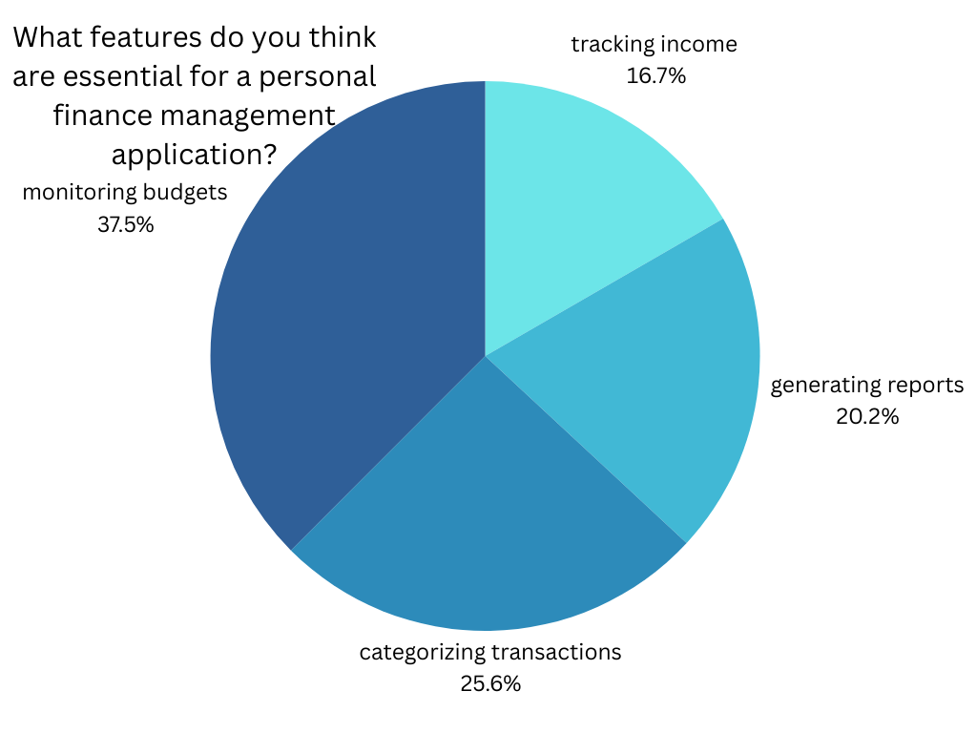

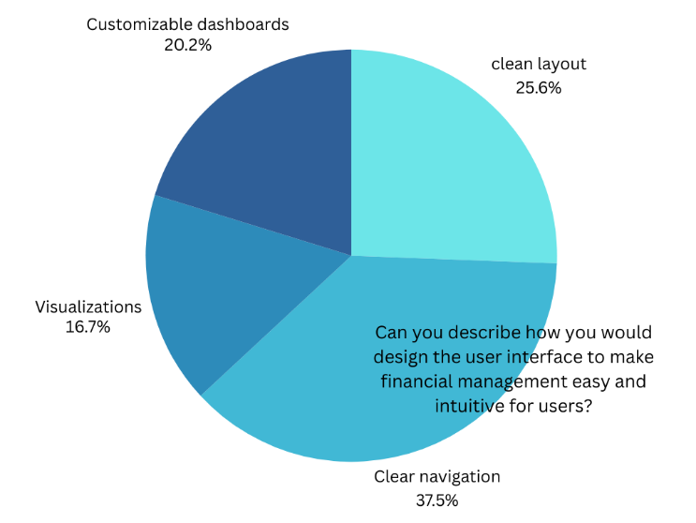

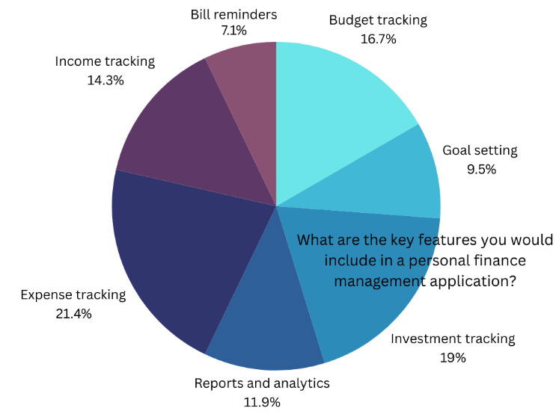

# Empathy Map

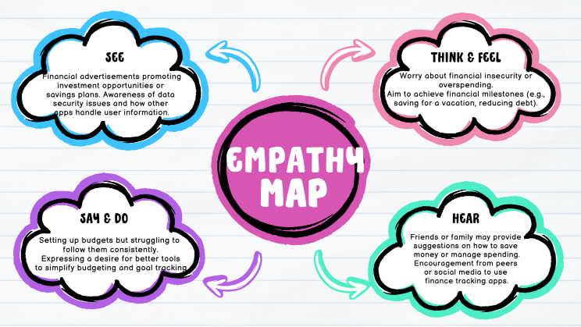

# Implementation

Front-End and Back-End Development:

The React front-end ensures a responsive and interactive user experience, while the Node.js back-end manages API calls and data processing. Both parts are implemented as consumable Web services exchanging data through the RESTful API.In the current work, the application in development utilizes React which ensures responsive Interactive and Intuitive UI. Following the same principles of React, the front end of the application divides every feature including the expenses, the budget, and the goals into components. This makes modification easy; the structure allows for scalability and a user interface that can render information in real time All thanks to modularity. By managing state through Redux or Reacts Context API users encounter no errors and all components run in parallel providing a flawless experience.

Technically, on application back end we can identify Node.js with Express framework responsible for application server functionalities, data processing and communication with front end part. Node.js back end mainly communicates with the server, manage and process users ‘data and business logics. Express allows for easy creation of RESTful API which helps both front end and back end to interact appropriately. These RESTful APIs act as the data intermediary between the front end and the back end, by which the front end can access user related data such as expense history, budget settings and user’s financial summary. This client-server disconnection increases flexibility and practicability since developers can upgrade either the front or back without great difficulty in the future.

Database Structure:

MongoDB with NoSQL structure is perfect for storing user data, expense categories, limits in form of documents that can easily be scaled up or down as needed. The database used in the application is MongoDB, which is a NoSQL database especially suitable to complex and evolving data. MongoDB is another type of database that supports flexible JSON-like documents, which means that it can save users, profiles, expenses, budgets and Goals data. This structure is scalable because it means the database in the application can grow with application while still creating room for more users and his or her data without causing a slowdown of the application.

Employee details, expense type, spending quotas and transaction history all fall under collections since these are the main data that the app requires for the computation of the recommended budget. Being a document-oriented database system, it may easily update the data schema adding new fields or updating the current data without any need for going offline. Such flexibility also makes it possible to expand functionality of the application in the distant future, for example, when the scope of expenses is expanded by including subcategories, or when more elaborate analysis of the budget is required.

API Integrations:

Bank APIs are available for the application to import the data directly from the bank, while foreign exchange APIs can be provided for multi-currency management for expenses. Covet is built to provide better usability and combine many APIs external to the application for the purpose of complete financial management. Bank APIs allow users to directly transfer data from their bank account, thus making all records real-time and accurate. This integration also makes the registration of expenditures easy since frequent users of the application will not be required to key in their expenditure details. Users can also access their account details and easily check their balance all through the use of Bank API in the app.

Also, exchange rate APIs are included to facilitate multi-currency operations, which may become significant for users who buy products or use services in other currencies or when they travel. Real-time exchange rate APIs enable the application to convert an expense amount into the user’s base currency and give the consolidated view of his expenditure. Besides, with the integration of the two components, the tracking of expenses in different currencies becomes less complicated supplemented with the improvement in accuracy while planning the budgets and financial processes.

# Data Visualization

Overview of Analytics Tools:

Chart.js is used to generate charts for spending distribution, budget compliance and expenses, in order to make the application more user-friendly.

Different Graphs or Charts for Deriving Financial Information:

Other types of reports embrace graphs of different expenses, the expenses distribution by months, and expenses for distinct categories. These visual tools help the user identify the way they spend their money and change their habits when necessary.

Interactions between people and Digitized Information Presentation:

Users could sort the data for time, category, or for some predefined budget, which sheds much light upon overall financial situation and could be quite utilizable.

Data visualization as a form of knowledge representation is a critical feature of any application that aims at helping a person manage his or her money since it facilitates the recognition of essential patterns at a glance. For presentation and ease of use certain styles of charts and graphs, are used in the app and each is meant to fulfill a specific function. This section focuses on the chief graphical tools implemented in our application, as well as the significance and the broader significance of these tools to the end-users.

1. Income vs. Expenses Chart

Purpose: This chart allows users to view the relation between their income and expenditure for a given period which could be monthly, quarterly or yearly.

Visualization Type: A bar or line chart is usually used to represent this data.

Insights: To this end, by presenting income together with expenses, users can check whether they spend too much or save enough money per month. It can also show when the expenses are usual high so that users can be equipped for the future budgeting.

2. Expense Breakdown by Category

Purpose: On this chart, one sees the expenses by heads like rent, food expenses, entertainment, transport etc.

Visualization Type: Pie chart or a donut chart is utilized to capture the proportion expenditure of each category in overall expenditure easily.

Insights: From the gathered information, users can find where they are expending much of their resources. For instance, if entertainment takes relatively a big slice of budgets, users can then be motivated to change such habits.

3. Savings Goals Progress

Purpose: For each user, this visualization represents progress towards personal savings targets specified by identified users.

Visualization Type: A bar graph or a circular graph is most suitable to show the progress concerning some financial targets.

Insights: Page authors help users remain motivated through contemplating how far from the intended savings goals one is. It also helps to set proper goals and offers satisfaction when seeing the progress as results are being tracked.

4. Historical Spending Trends

Purpose: Climbing the graph depicts the spending achievements of the user in the past periods.

Visualization Type: A chart that uses lines to show how much has been spent in different periods of time.

Insights: Users can detect changes in their spending behavior, and even see how much they tend to spend during certain months of the year due to occasions such as Christmas. This is very beneficial when it comes to personal budgeting for the long term.

5. Budget Utilization Chart

Purpose: To guide users in managing the assigned budget by giving them a quantitative measure of the used budget for each category.

Visualization Type: It is customary to use stacked bar charts or progress bars to provide the budget and spending indicators within each category.

Insights: Users can obtain accurate checks and balances by comparing the actual expenditure with the budgeted amount and are effective at preventing over-expenditure in aspects they are not fully aware of.

All the visualizations presented here are also clickable; users can change the time frames, zoom in on subcategories, and follow trends dynamically. Collectively they assist the users gain a complete view of the firm’s status hence enable them make proper decisions.

# User Experience and Interface Design

Design and Usability Guidelines of Financial Applications:

From the appearance, you are able to note that there is no clutter and the whole concept of the interface looks simple and easy to use. Common key performance indicators include cost, volume, client, product, and period to which figures refer, presented in a manner to allow for instant decision making.

A few notes on accessibility and usability must be made here:

* flexible font settings
* switch to the dark mode
* voice support help to involve as many users as possible with specific needs to manage their personal finances.

Dashboard and Navigation Flow:

Main dashboard is a summary of today’s costs, budget compliance and financial targets. Being in a corporate environment, the organization that can be seen is clear and having links to the Expense Tracker, Budget Tracker, and other similar areas are well placed for easy navigation.

In the context of developing a personal finance management application, the crucial value that needed to be delivered to the user base was an excellent UX. Unfortunately, the design must be cohesive so that the user becomes comfortable with one particular interface and functions as a tool in managing their finances. In this section, the reader will learn about important components of user experience design and how they influence the usage of the presented application.

User-Centric Design: The design process of the application put into consideration concepts of user experience design. Therefore, to identify primary user requirements and expectations regarding the finance management application, our team studied common expectations from these applications, primarily ease of use, app design and quick processing. This helped in decision making when creating the app so that even those who are not very much in touch with technology can still be easily be able to move through the app.

Clear Navigation: It’s very easy to navigate within the application using the navigation menu that is quite simple and minimalist, showing only the dashboard, a tool for tracking expenses, the budget, and the reports. Elements are divided logically and distinguished by easily searchable labels, end-user hints are placed in the context, explanations of many details do not require complex lessons.

Personalization: SRS integration was done to have a sense of relevance and interactivity so that the users of the app feel that the app is built and designed just for them. For example, users can pursue individual targets with regards to the expenditure or keep track of distinct categories of expenses, along with approach personalized recommendations arising out of users’ spending behavior. Personalization is more effective for users in terms of identifying a closer connection between an application and its value in their financial relations.

Data Visualization: The application employs charts and graphs to convey details of spending patterns and trends, the amount of progress achieved towards budgeting and other financial related data. As for the present VSs’ rationale, they help break down multifaceted information and turn it into actionable insights that allow to grasp the state of one’s financial situation with a few looks at the respective diagrams. Different graphs are inserted on the dashboard as well as on reports, enabling users to recognize, say, periods of high expenditure or overall, category specific rates of increase in spending.

Interactive Feedback: ” There was consensus regarding real-time feedback as being paramount for encouraging participation and maintaining users ‘attention. Alerts in the app include when a user gets close to or crosses his/her spending limits, enters a transaction, or sets new goals. Such dynamic alerts are helpful as they continuously lead users to appropriate content according to the defined spending plans.

Mobile Responsiveness: Happily, given the need for these services and access to them, the app was developed with a responsive interface in mind. The desktop and mobility versions allow users control over data and their finances with the ability to input expenses or review budgets from a desktop or a portable device. This functionality becomes critical given that users mostly use the internet via mobile devices.

Security and Privacy: Security concerns are crucial in all applications but even more so in financial services. They use secure connections, forced authentication, and encryption of the connection as well as storing data. This way, security is on top of the list ensuring that the users have confidence in the app and allow for the storage of their other sensitive financial details as well.

Engaging Chatbot: The app also features a chatbot for all the basic queries including, budgeting, expenses tracking, and other frequently asked financial questions. This is more effective than static tutorials, as it is interactive and simply taps the users on their wrist with instructions to help them to use the app properly.

By limiting itself to these components of the UX, the application provides a comfortable and efficient setting for the users of the finances’ management. Such careful design is supposed to make people use the application over and over again, thus helping them keep practicing better money management.

# Testing And Validation

Core Feature Testing:

The front end of the application gets unit tested, the API calls get integration tested and the user workflows get end to end tested.

User Testing and Feedback:

In the UT sessions it is observed where the changes have to be made, what is more important, easy navigation, design or certain features of the interface. It has been found that feedback facilitates in improvement of the characteristics of the app and ensure they meet the needs of the users.

Security and Performance testing:

The application is checked for susceptibility to an attack for instance SQL injection and cross site scripting. This emerged from the performance testing to make sure that the app will run well in different devices and connectivity.

Checking is critical for the completeness of a financial management application before being released to the general public via the ITunes store. In the present work, functional testing, usability testing, and performance testing with data integrity checks and security assessments have been addressed. Here’s an overview of the testing methods used:

1. Unit Testing

Objective: A way to ensure that individual components which have been broken down like the expense tracking feature or the existence of budgeting capabilities really work.

Tools Used: Java is for JavaScript, de Mocha/Chai is to Node.js.

Method: Every single function and component of the program – the calculations made on the data, as well as the student inputs – were checked in isolation for the highest level of accuracy for as many different variants as possible.

Results: First, unit testing prevented some embarrassing mistakes in every function starting from data calculations up to displayed incomes and expenses values.

2. Integration Testing

Objective: To enable modules that compose the application to successfully communicate with each other (backend, frontend and the database).

Method: We experimented with the ways to fetch data, Levels of detail for API connections for actual time data (such as ora rates), transitions between modules and frames.

Results: The integration testing proceeded verifying whether the modules cooperated as anticipated, for example when fetching and presenting data upon the use of input devices.

3. End-to-End (E2E) Testing

Objective: To mimic actual user experience including registration and login, creating expenses and organizing them into categories as well as evaluation of the budget.

Tools Used: Cypress for developing applications for browser testing.

Method: End to end scenarios were carried out to ensure that the application is fully functional.

Results: Evaluating the end-to-end, there were no problems with the case when users tested all the features of the application successively.

4. Performance Testing

Objective: In order to determine how different load condition affects the application.

Method: Stress tests involved monitoring response time, and RAM usage where applicable—for example, on the dashboard since it contains a lot of data.

Results: It performed well where I threw an average of loads of different users with acceptable level of response on some database intensive pages.

5. Security Testing

Objective: In order to protect sensitive financial data from access by unauthorized personnel, from malicious threats or intrusions.

Method: We also performed a check for the Input validation for SQL injection and attempted a Cross site scripting attack and we also checked the JWT authentication for proper access.

Results: Validation of the security aspect confirmed an efficient shield against unauthorized access and final data leakage.

# Discussion

Advantages of the Application for Users:

The specific application allows having track of expenses, keeping budgets, and thus fostering users’ decision-making to make correct choices.

Facts, Issues and Concerns of Development and Data Privacy:

The peculiarities of data protection while maintaining the interface ‘s friendliness for users were the major concerns: secure authentication and encrypted storage.

Assessment of Similar Current and Standard Financial Applications:

Unlike many different tools, this application is not designed to be monotonous with a strong emphasis on return-oriented interactions, real-time recommendations, and comprehensive prospect’s financial data analysis.

The app for the personal financial management features a clean interface and lots of functionalities for keeping track of money. This is in the areas of budgeting, expense tagging, and savings goal setting, the whole of which is backed by neatly designed graphics and live data.

The tools do provide the users with a way of engaging with and analyzing their financial data. A flexible structure of views and filters allows users to get a transparent picture of their expenses, savings and spending of the budgets. This approach helps to make sense of difficult to understand financial information and promotes prudent financial handling.

Again, the tests revealed how this application would prove to be strong and reliable and the security checks reinforced confidence when dealing with secure information. Among all the features, users had a positive response, especially for the ease of use of the dashboard and data visualization.

Challenges and Limitations:

The first significant problem was related to the correctness of expenditures, established financial plans, and the achieved level of savings indicators. Financial data enters many user interactions, and mistakes are costly for trust; testing and verifying were essential. The last concern was the incorporation of the third party information such as real-time currency exchange rates for handling the multi currency transactions that provided additional difficulty in the both the presentation and the logic layers.

Future Enhancements:

Looking ahead, potential enhancements include:

AI-Based Expense Predictions: Appending predictions for the future expenses based on the spending patterns as a feature of the framework.

Investment Tracking: Plug-ins to monitor the investments, and offer the clients a better picture of their finances.

Enhanced Security: To add that extra layer of compliance and security utilising two-factor authentication.

Expanded Multi-Currency Support: Of providing more international financial institutions to its users for those who deal with cross border affairs.

This application can be further developed into an efficient e-Finance application useful to different category of users with different financial requirements and objectives. As a result, using feedback received from users, as well as iterations in technologies, the application can help users become more financially smart and improve their financial conditions.

# Conclusion And Future Work

Summary of Achievements:

The Personal Finance Management application has appropriate expense tracking feature, budget control, analytics, and chatbot support features that enhance financial skill and budget compliance.

Challenges of the Existing System:

The current system could use more integrations of bank API for automatic expense recording and better multi-currency experience to global audience.

Future Improvements and Future Studies suggestions:

Further plans include introducing more sophisticated financial analytics based on the use of artificial intelligence, extend the number of currencies, and enhance other goal striving tools to provide users with even better possibilities to reach long-term financial planning goals.

This personal finance management application puts at the fingertips of the user basic tools for budgeting, expenses tracking, and financial literacy. In designing the features, the user can have something that they need to know in the area of financial management, security of data, and goal setting to ensure that they upgrade in a better way in future. The future development is to connect with banking APIs for automatic tracking, to include AI financial information, and develop community sharing for people’s learning. Improving the possibility to protect data and develop user-friendly products will always stay critical to guarantee their confidence and interested in our future products.

Thus, the personal finance management application created in this project meets a vital requirement for easily usable and efficient monetary management tools. The convenient and user-friendly navigation along with the features of budgeting and real-time financial analysis gives the application all the capabilities to help the user become more financially stable, plan the expenses correctly and set realistic financial goals.

Key takeaways from this project include:

Empowering Users with Financial Insights: Users make their spending patterns easily interpretable and interactive which is very important in creating awareness on spending and ensuring that users make correct decisions in their spending. It provides the user with actual figures (data) and not mere guess work to enable the user to come up with strategies which will stand a better chance of working.

Personalization and Adaptability: The ability of the app to state a budget for oneself and manage the general expenses according to users’ preferences in different categories make the app personalized and seem to be developed especially for every user. This reusability makes a high chance of long-term usage because the user will always be inclined to use an application that suits his or her purpose and or financial capacity.

Security and Trust: Anti-virus technology, a secure socket layer connection as well as encryption of data kept on the website rein down user’s privacy as the bank ensures that unauthorized persons do not access this information. This layer of protection is base in financial applications where the privacy of the user is of great importance and will go along way at creating a trust between the user and the application.

Positive User Experience: By following this approach in design, it makes the application much more friendly to the user then it would be of it was developed with IT professionals in mind. Elements such as the integrated chatbot, responsiveness to mobile devices, and the clear and simple boards create user engagement and expense management engagements.

Scalability for Future Development: The application architecture also allows for future upgrades such as, multiple currency support, settlement institution interface, and profound data analysis. This makes the application to be future expandable in that it will have the capability to expand as users needs begin to change over time.

Looking Ahead

Thus, the development of the project can be continued by adding the features of less constrained spending insights, the acceptance of different currencies, as well as adopting APIs to work with financial organizations. These extra features would enhance the application, making it a true financial tool that would also satisfy a lot of other customers’ requirements.

Also, more exploratory work could be done on feedback and usage from the users to enhance the functions of the app and the quality of an application. Both of these updates and improvement will go a long way in maintaining the relevance and rating of the application particularly in light of ongoing development in financial technologies.

Overall, this project shows extent to which an effective and efficient personal finance application can transform people’s financial behavior. It also helps enables users who are also the consumers of the application to track their goals and expenses hence achieving more financial efficiency. With increasing technological advancement in the sector of personal finance, mobile applications such as this one will act as ‘financial enablers’.

##### Acknowledgment

Therefore on behalf of all of us I would like to thank everybody who in one way or another supported the completion of the personal finance management application project. It appreciates the kind support, useful guidance, and moral encouragement from several people and organizations.

I would like to express the most sincere gratitude to our faculty for their profound advice, critical comments, and encouragement during the work on the project. Many thanks for sharing their knowledge and participating in the discussion which helped to shape and improve this endeavor.

I would also like to thank teachers whose feedback and ideas were instrumental in enhancing one or the other part of this work. Huge appreciation goes to all the team members for their contribution, encouragement and commitment towards the work done.

Thanks to our organization for giving us the support, information or assistance that made this project possible. This support had a great help to analyze the situational part of the given application.

Last but not least, the sincere thanks to the family and friends who supported me during the thesis writing process. It proved their encouragement and this makes a person achieve his or her goals as intended.

All those who have participated, in any capacity, to help in the completion of this project are appreciated. To have you on my team has been most helpful and your encouragement so appreciated.

##### References

1. Bajaj, A., & Agrawal, V. (2018). *Personal Financial Management: A Guide to Making Financial Decisions.* Financial Times Press.
2. Friedman, A. (2020). "The Role of Technology in Modern Personal Finance." *Journal of Financial Services Marketing*, 25(3), 221-229. doi:10.1057/s41264-020-00064-4
3. Kumar, S., & Bhatt, A. (2021). "User-Centered Design Approaches for Financial Applications." *International Journal of Human-Computer Interaction*, 37(4), 315-330. doi:10.1080/10447318.2020.1833546
4. Li, Z., & Chen, X. (2019). "A Study on Personal Finance Management Systems Using Data Visualization." *Proceedings of the 2019 International Conference on Information Management.* IEEE. doi:10.1109/ICIM.2019.8776498
5. Medola, M., & Oliveira, A. (2021). *Designing Financial Apps for the Digital Age.* Springer.
6. Money Advice Service. (2020). "Budgeting and Personal Financial Management." Retrieved from <https://www.moneyadviceservice.org.uk>
7. Nguyen, T., & Tanaka, H. (2022). "Security Practices for Personal Finance Applications: A Review of Authentication and Encryption Protocols." *Cybersecurity and Privacy Journal*, 5(2), 97-108.
8. Oberlechner, T., & Zagst, R. (2018). "User Behavior in Financial Applications: An Empirical Analysis." *Journal of Behavioral Finance*, 19(4), 348-360. doi:10.1080/15427560.2018.1515059
9. Oliveira, P., & Castro, R. (2019). "Exploring Machine Learning in Personal Finance Applications." *Journal of Financial Data Science*, 1(2), 54-68. doi:10.3905/jfds.2019.1.2.054
10. Park, S. (2020). "Evaluating the Usability of Mobile Personal Finance Apps." *Journal of Financial Planning*, 33(1), 31-39.
11. Patel, R., & Smith, D. (2021). *Building a Financial Dashboard for Personal Money Management.* O'Reilly Media.
12. PricewaterhouseCoopers. (2022). *Digital Financial Literacy and Inclusion: A Guide for Modern Financial Applications.* PwC Research Report.
13. Tufte, E. R. (2006). *The Visual Display of Quantitative Information.* Graphics Press.
14. World Economic Forum. (2021). "The Role of Digital Financial Tools in Promoting Financial Wellness." Retrieved from <https://www.weforum.org>
15. Zilinski, C., & Young, M. (2019). "Challenges in the Design of Personal Finance Management Applications." *Human-Computer Interaction Conference Proceedings*, 112-119.
16. Zhang, L., & Lee, Y. (2018). "Privacy Concerns in Personal Financial Management Apps: A Cross-Sectional Analysis." *Information Systems Journal*, 28(2), 345-358. doi:10.1111/isj.12153
17. Zick, C. D., & Mayer, R. N. (2018). "Promoting Financial Literacy Through Digital Tools." *Journal of Financial Counseling and Planning*, 29(3), 358-372. doi:10.1891/1052-3073.29.3.358
18. Jones, P., & Malik, M. (2020). "The Impact of Goal-Setting on Personal Financial Management." *International Journal of Financial Planning*, 15(1), 27-34.
19. Rosenfeld, L., & Morville, P. (2015). *Information Architecture for the Web and Beyond.* O'Reilly Media.
20. Thompson, R., & Carlson, K. (2021). "Evaluating Financial Management Tools for Usability and Accessibility." *Journal of Digital Finance*, 4(1), 89-102. doi:10.1007/s42521-021-00047-7